COMPETITIVE ADVANTAGE

ANALYSIS

COMPANY 1 COMPANY 2

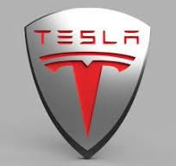

# P&G

* Procter & Gamble Company (P&G) is a multinational consumer goods corporation headquartered in Cincinnati, Ohio. With a rich history dating back over 180 years, P&G is recognized as one of the largest and most influential companies in the consumer goods industry. The company boasts a diverse portfolio of brands spanning various categories including personal care, grooming, home care, and baby care. Some of its well- known brands include Pampers, Gillette, Tide, Pantene, and Crest. P&G is widely acclaimed for its innovation, quality, and commitment to improving the lives of consumers worldwide through its wide range of products.

# TESLA

* Tesla, Inc. is a pioneering electric vehicle (EV) and clean energy company headquartered in Palo Alto, California. Founded in 2003 by Elon Musk,

Tesla is renowned for revolutionizing the automotive industry with its innovative approach to sustainable transportation. The company's primary focus is on designing, manufacturing, and selling electric

vehicles, including premium electric cars like the Model S, Model 3, Model X, and Model Y, as well as energy products such as solar panels and energy storage solutions. Tesla's cutting-edge technology, sleek

designs, and commitment to environmental sustainability have propelled it to the forefront of the EV market, making it a symbol of innovation and progress in the automotive sector.

# PURPOSE OF ANALYSIS

* Identifying Competitive Advantages: Explore and assess the unique strengths and advantages possessed by Tesla and P&G. This includes factors such as brand reputation, product differentiation, technological innovation, market leadership, economies of scale, and distribution

networks.

* Evaluating Financial Performance: Analyze the financial performance of Tesla and P&G, emphasizing key metrics such as revenue growth, profit margins, return on investment, and market share. Assess how their competitive advantages have contributed to their financial success.
* Comparing Competitive Positions: Conduct a comparative analysis of the competitive positions of Tesla and P&G within their respective industries. Consider factors such as market share, growth prospects, competitive threats, and barriers to entry to understand their relative standings.
* Assessing Sustainability: Evaluate the sustainability of the identified competitive advantages for both Tesla and P&G. Determine whether these strengths are likely to endure over the long term or if they are

vulnerable to industry changes, technological disruptions, or competitive pressures.

* Providing Investment Recommendations: Based on the analysis, offer insights and recommendations for investment decisions. Highlight potential opportunities and risks associated with investing in Tesla and

P&G, considering their competitive advantages and sustainability factors.

# P&G OVeR VIEW

Company Name: The Procter & Gamble Company

Headquarters: Cincinnati, Ohio, United States

Industry: Consumer Goods

Founded: 1837

Overview:

The Procter & Gamble Company, commonly known as P&G, is one of the world's largest and most diversified consumer goods corporations. Established in 1837 by William Procter and James Gamble, P&G has grown into a global powerhouse with a wide range of well-known brands in various consumer product categories.

Product Portfolio:

P&G's product portfolio encompasses a diverse array of consumer goods, including:

Personal Care: Brands like Pantene, Head & Shoulders, Gillette, Olay, and Old Spice.

Grooming: Razor and grooming products under the Gillette brand.

Home Care: Household cleaning products such as Tide, Febreze, Mr. Clean, and Swiffer.

Baby Care: Baby diapers and wipes under the Pampers brand.

Health Care: Oral care products like Crest and Oral-B.

Market Presence:

P&G has a strong presence in both developed and emerging markets worldwide. Its brands are household names, trusted by consumers for quality and effectiveness. The company's products are sold through various channels, including retail stores, supermarkets, pharmacies, and online platforms.

Innovation and Research:

P&G places a significant emphasis on innovation and research to drive growth and stay ahead in the highly competitive consumer goods industry. The company invests heavily in research and development to create innovative products that meet evolving consumer needs and preferences.

Sustainability Initiatives:

P&G is committed to sustainability and environmental responsibility. The company has implemented various initiatives to reduce its environmental footprint, including efforts to minimize waste, conserve water and energy, and use sustainable sourcing practices for raw materials.

Financial Performance:

P&G consistently delivers strong financial results, with steady revenue growth and healthy profit margins. The company's robust performance is driven by its portfolio of leading brands, continuous innovation, and effective marketing strategies.

Corporate Social Responsibility:

P&G is actively involved in corporate social responsibility (CSR) initiatives aimed at making a positive impact on communities and society. These initiatives include programs focused on education, health and hygiene, gender equality, and environmental sustainability.

Overall, The Procter & Gamble Company is a global leader in the consumer goods industry, known for its iconic brands, commitment to innovation, and dedication to making a positive difference in the world.

# TESLA OVERVIEW

* 1. Company Name: Tesla, Inc.
  2. Headquarters: Palo Alto, California, United States
  3. Founded: 2003
  4. Overview:

Tesla, Inc. is a pioneering electric vehicle (EV) and clean energy company founded by Elon Musk, JB Straubel, Martin Eberhard, Marc Tarpenning, and Ian Wright. Tesla is renowned for its groundbreaking approach to sustainable transportation and energy solutions.

* 1. Electric Vehicles (EVs):

Tesla specializes in designing, manufacturing, and selling electric vehicles (EVs) that offer zero-emission transportation alternatives. The company's lineup of EVs includes:

* 1. Tesla Model S: A premium electric sedan known for its

performance, range, and advanced technology features. The Model S offers impressive acceleration, long-range capabilities, and luxurious interior amenities.

* 1. Tesla Model 3: A midsize electric sedan designed for mass-market appeal, offering a more affordable entry point into the Tesla ecosystem.

The Model 3 combines range, performance, and safety features in a sleek and minimalist design.

* 1. Tesla Model X: An all-electric SUV with falcon-wing rear doors, offering spacious seating for up to seven passengers and cutting-edge

safety features. The Model X delivers versatility, performance, and innovative design elements.

* 1. Tesla Model Y: A compact electric SUV that combines the functionality of a crossover with the performance and efficiency of an electric vehicle. The Model Y offers ample cargo space, advanced

technology, and a commanding driving experience.

* 1. Tesla Roadster (upcoming): Tesla's original electric sports car, known for its high performance and acceleration capabilities. The next- generation Tesla Roadster promises even more impressive performance metrics, including record-breaking acceleration and range.
  2. Autopilot and Full Self-Driving Capability:

Tesla vehicles come equipped with advanced driver-assistance features, including Autopilot, which offers semi-autonomous driving capabilities such as adaptive cruise control, lane-keeping assistance, and automatic lane changes. Additionally, Tesla offers a Full Self-Driving (FSD) package, which aims to enable fully autonomous driving in the future through over-the-air software updates.

* 1. Supercharger Network:

Tesla has developed a proprietary Supercharger network, consisting of fast-charging stations strategically located along highways and major travel routes. The Supercharger network allows Tesla owners to recharge their vehicles quickly and conveniently, facilitating long-distance travel.

* 1. Innovation and Sustainability:

Tesla is at the forefront of automotive innovation, continuously pushing the boundaries of electric vehicle technology. The company focuses on sustainability, aiming to accelerate the world's transition to sustainable energy by producing electric vehicles and renewable energy solutions.

Overall, Tesla cars are known for their cutting-edge technology, high

performance, long-range capabilities, and commitment to sustainability, making them popular choices among consumers seeking environmentally friendly transportation alternatives.

* P&G FAcTORS BASeD ON cOMPeTITIVe ADVANTAGe

1. Brand Reputation:

P&G boasts a strong brand reputation with a portfolio of well-established and trusted brands in various consumer goods categories.

Brands like Pampers, Tide, Gillette, and Pantene are household names globally, known for quality and reliability.

P&G's brand reputation contributes to consumer trust and loyalty, enhancing its competitive position in the market.

1. Product Differentiation:

P&G focuses on product differentiation by offering innovative and unique features in its products.

The company invests in research and development to create differentiated formulations, packaging, and marketing strategies.

For example, Pampers offers diapers with advanced features for different stages of a baby's development, while Tide provides various formulations tailored to different laundry needs.

1. Technological Innovation:

P&G prioritizes technological innovation to stay ahead in the competitive consumer goods market.

The company invests in cutting-edge research and development to develop new products and improve existing ones.

Technological advancements are seen in product formulations, packaging design, manufacturing processes, and sustainability initiatives.

1. Market Leadership:

P&G holds significant market leadership positions in several consumer goods categories.

The company is a leader in segments such as baby care (Pampers), fabric care (Tide), grooming (Gillette), and oral care (Crest).

P&G's market leadership is reinforced by its strong brand portfolio, innovation capabilities, and extensive distribution network.

1. Economies of Scale:

P&G benefits from economies of scale due to its large-scale operations and global presence.

The company leverages its size to achieve cost efficiencies in manufacturing, procurement, and distribution.

Economies of scale enable P&G to offer competitive pricing, invest in research and development, and maintain profitability.

1. Distribution Network:

P&G has an extensive distribution network that reaches consumers worldwide.

The company's products are available in various retail channels, including supermarkets, pharmacies, online platforms, and convenience stores.

P&G's distribution network ensures broad market coverage and accessibility for consumers, supporting its market leadership and revenue growth.

Overall, The Procter & Gamble Company demonstrates strong competitive advantages across factors such as brand reputation, product differentiation, technological innovation, market leadership, economies of scale, and distribution network, positioning it as a dominant player in the global consumer goods industry.

## TeSLA FAcTORS BASeD ON cOMPeTITIVe ADVANTAGe

1. Brand Reputation:

Tesla has built a strong brand reputation as a pioneer in the electric vehicle (EV) industry. The company is associated with innovation, sustainability, and cutting- edge technology. Tesla's brand is synonymous with high-performance EVs and is highly regarded by consumers and investors alike.

1. Product Differentiation:

Tesla differentiates itself through its focus on electric vehicles with advanced technology and design. The company offers a range of EV models, including sedans, SUVs, and sports cars, known for their long-range capabilities,

performance, and innovative features. Tesla's Autopilot and Full Self-Driving (FSD) capabilities provide additional differentiation, offering semi-autonomous and autonomous driving features.

1. Technological Innovation:

Tesla is a leader in technological innovation within the automotive industry. The company continuously introduces new features and improvements through over-the-air software updates, enhancing the functionality and

performance of its vehicles. Tesla's battery technology, electric drivetrains, and energy storage solutions are considered state-of-the-art, driving innovation in the EV market.

1. Market Leadership:

Tesla holds a significant market leadership position in the electric vehicle

segment. The company has achieved widespread adoption and recognition for its EVs, surpassing traditional automakers in terms of market capitalization and

valuation. Tesla's Model S, Model 3, Model X, and Model Y are among the best- selling EVs globally, solidifying its leadership in the market.

1. Economies of Scale:

Tesla benefits from economies of scale as it continues to ramp up production and expand its manufacturing capabilities. The company's Gigafactories enable large-scale production of batteries and vehicles, driving down costs and improving efficiency. Tesla's increasing production volumes allow it to leverage economies of scale, resulting in cost savings and competitive pricing for its

vehicles.

1. Distribution Network:

Tesla has a unique distribution model that includes company-owned stores and galleries, online sales, and a direct-to-consumer approach. The company's distribution network emphasizes direct sales to consumers, bypassing traditional dealership networks. Tesla's direct sales model enables greater control over the customer experience and facilitates faster adoption of new

technologies.

Overall, Tesla demonstrates strong competitive advantages across factors such as brand reputation, product differentiation, technological innovation, market leadership, economies of scale, and distribution network, positioning it as a

leader in the electric vehicle industry.

* + FINANcIAL PeRFORMANce OF P&G.

The Procter & Gamble Company reported earnings results for the second quarter ended December 31, 2023. For the second quarter, the company

reported sales was USD 21,441 million compared to USD 20,773 million a year ago. Net income was USD 3,468 million compared to USD 3,933 million a year ago. Basic earnings per share from continuing operations was USD 1.44 compared to USD 1.63 a year ago. Diluted earnings per share from continuing operations was USD 1.4 compared to USD 1.59 a year ago.

INCOME STATEMENT

|  |  |
| --- | --- |
| Gross margin **TTM** | 50.55% |
| Operating margin **TTM** | 24.9% |
| Net Profit margin **TTM** | 17.6% |
| Return on Investment **TTM** | 20.11% |

|  |  |  |  |  |
| --- | --- | --- | --- | --- |
| Title | Dec 31, 2023 | Sep 30, 2023 | Jun 30, 2023 | Mar 31, 2023 |
| Total Revenue | 21,441 | 21,871 | 20,553 | 20,068 |
| Gross Profit | 11,297 | 11,370 | 10,100 | 9,664 |
| Operating Income | 5,775 | 5,765 | 4,822 | 4,334 |
| Net Income | 3,468 | 4,521 | 3,384 | 3,39 |

BALANCE SHeeT

|  |  |
| --- | --- |
| Quick Ratio **MRQ** | 0.4 |
| Current Ratio **MRQ** | 0.64 |
| LT Debt to Equity **MRQ** | 48.39% |
| Total Debt to Equity **MRQ** | 70.64% |

|  |  |  |  |  |
| --- | --- | --- | --- | --- |
| Title | Dec 31, 2023 | Sep 30, 2023 | Jun 30, 2023 | Mar 31, 2023 |
| Total Assets | 120,709 | 122,531 | 120,829 | 119,851 |
| Total Liabilities | 71,880 | 74,518 | 73,764 | 74,430 |

|  |  |  |  |  |
| --- | --- | --- | --- | --- |
| Title | Dec 31, 2023 | Sep 30, 2023 | Jun 30, 2023 | Mar 31, 2023 |
| Total Equity | 48,829 | 48,013 | 47,065 | 45,421 |

## CASH FLOW STATeMeNT

|  |  |
| --- | --- |
| Cash Flow/Share **TTM** | 8.15 |
| Revenue/Share **TTM** | 35.61 |
| Operating Cash Flow | 14.19% |

|  |  |  |  |  |
| --- | --- | --- | --- | --- |
| Title | Dec 31, 2023 | Sep 30, 2023 | Jun 30, 2023 | Mar 31, 2023 |
| Cash From Operating Activities | 5,100 | 4,904 | 5,341 | 3,863 |
| Cash From Investing Activities | -1,002 | -1,222 | -798 | -1,380 |
| Cash From Financing Activities | -6,049 | -2,038 | -3,893 | -1,753 |
| Net Change in Cash | -1,843 | 1,487 | 650 | 742 |

MARKET SHARE

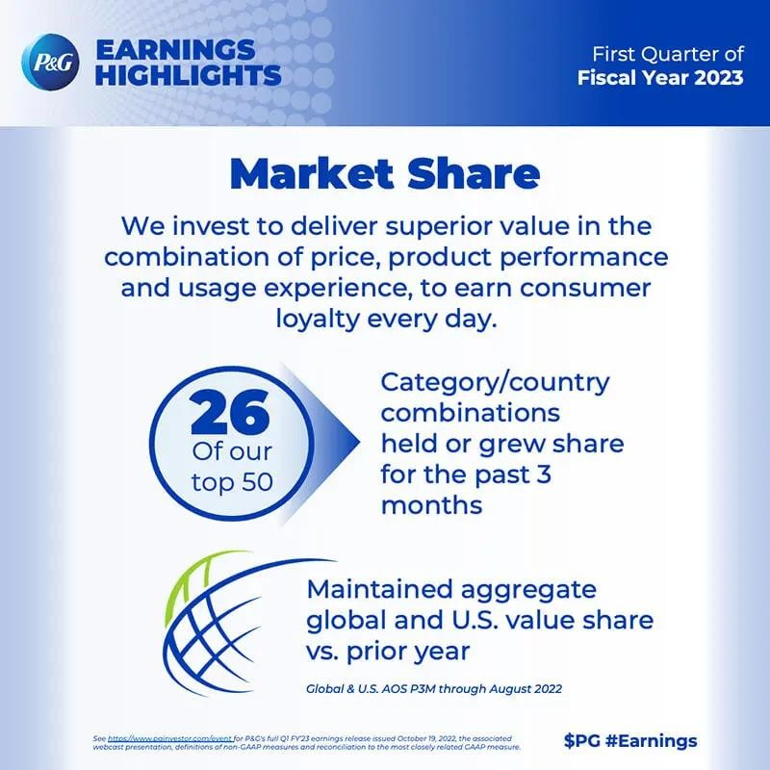

FINANcIAL PeRFORMANce OF TeSLA

1. INcOMe STATeMeNT

|  |  |
| --- | --- |
| Gross margin **TTM** | 18.25% |
| Operating margin **TTM** | 9.19% |
| Net Profit margin **TTM** | 15.5% |
| Return on Investment **TTM** | 12.11% |

|  |  |  |  |  |
| --- | --- | --- | --- | --- |
| Title | Dec 31, 2023 | Sep 30, 2023 | Jun 30, 2023 | Mar 31, 2023 |
| Total Revenue | 25,167 | 23,350 | 24,927 | 23,329 |
| Gross Profit | 4,438 | 4,178 | 4,533 | 4,511 |
| Operating Income | 2,064 | 1,764 | 2,399 | 2,664 |
| Net Income | 7,928 | 1,853 | 2,703 | 2,513 |

BALANce SHeeT

|  |  |
| --- | --- |
| Quick Ratio **MRQ** | 1.14 |
| Current Ratio **MRQ** | 1.73 |
| LT Debt to Equity **MRQ** | 4.28% |
| Total Debt to Equity **MRQ** | 15.28% |

|  |  |  |  |  |
| --- | --- | --- | --- | --- |
| Title | Dec 31, 2023 | Sep 30, 2023 | Jun 30, 2023 | Mar 31, 2023 |
| Total Assets | 106,618 | 93,941 | 90,591 | 86,833 |
| Total Liabilities | 43,009 | 39,446 | 38,409 | 37,598 |
| Total Equity | 63,609 | 54,495 | 52,182 | 49,235 |

## CASH FLOW STATeMeNT

|  |  |
| --- | --- |
| Cash Flow/Share **TTM** | 4.17 |
| Revenue/Share **TTM** | 30.44 |
| Operating Cash Flow | 15.20% |

|  |  |  |  |  |
| --- | --- | --- | --- | --- |
| Title | Dec 31, 2023 | Sep 30, 2023 | Jun 30, 2023 | Mar 31, 2023 |
| Cash From Operating Activities | 4,370 | 3,308 | 3,065 | 2,513 |
| Cash From Investing Activities | -4,804 | -4,762 | -3,534 | -2,484 |
| Cash From Financing Activities | 887 | 2,263 | -328 | -233 |
| Net Change in Cash | 599 | 711 | -891 | -154 |